Deliverable D4.1
Platform for Data Management

Work Package 4
MONITOR
Version: Add the version number of the deliverable (1.0/2.0/Final)

Deliverable Overview
Include a summary of the deliverable. This should match the description in the Grant Agreement.

Additional Information
Type: e.g. R – Document, report (check Grant Agreement)
Dissemination Level: e.g SEN – Sensitive (check Grant Agreement)
Official Submission Date: Add delivery date of the deliverable

Actual Submission Date: Add the submission date of the deliverable

Disclaimer
This document contains material, which is the copyright of certain EDIAQI partners, and may not be reproduced or copied without permission. All EDIAQI consortium partners have agreed to the full publication of this document if not declared “Confidential”. The commercial use of any information contained in this document may require a license from the proprietor of that information. The reproduction of this document or of parts of it requires an agreement with the proprietor of that information.

Document Revision History
Version | Date | Description | Partners
V1.0 | 14th March 2023 | 1st draft of deliverable | KNOW
V1.1
V2.0
V2.1
FINAL

Authors and Reviewers

Authors
- Add names of authors
- Add names of authors

Reviewers
- Add names of reviewers
- Add names of reviewers

Statement of Originality
This deliverable contains original unpublished work except where clearly indicated otherwise. Acknowledgement of previously published material and of the work of others has been made through appropriate citation, quotation or both.

Table of Contents
Deliverable Overview 2
Additional Information 2
Type: 2
Dissemination Level: 2
Official Submission Date: 2
Actual Submission Date: Add the submission date of the deliverable 2
Disclaimer 3
Document Revision History 3
Authors and Reviewers 3
Authors 3
Reviewers 3
Statement of Originality 3
Table of Contents 4
List of Figures 7
List of Tables 8
List of Terms and Abbreviations (Please update) 9
Executive Summary 10
1. Introduction 10
1.1 The challenge 10
1.2 Project objectives 10
1.3 Legal basis 10
2. Data Providers 13
2.1 Executive Board 13
2.2. Data Providers 13
3. Types of Data 14
3.1. Physio-Chemical Properties of Indoor Air Pollutants in Different Environments 14
3.2 Biological (Human) Samples 3.3 Toxological Data 14
3.4 Chemical Structure Information 14
3.5 Geographical Locations 14
3.6 Contamination Levels 14
3.7 Data Formats 3.7.1 On-Line Databases Relational, NoSQL, ObjectDB, XML, DB 3.7.2 Off-Line Files MS Excel, MS Access, CSV Files 3.7.2 Web Services 14
4. How Data are Managed 15
4.1. Open-Source / Open Data 15
4.2. FAIR 16
4.3. GDPR and Privacy 16
4.4. Creative Commons License 16
4.5. Granularity Level 16
4.6. Levels of Data 16
4.7 Data Restrictions 16
5. Demo of Data Platform / Front-End 17
6. IPCHEM Standards 18
6.1 Chemical Occurrence Data in IPCHEM 18
6.2 Contributors to IPCHEM 18
6.3 Purpose of IPCHEM 18
6.4 Data Forms 18
Annex 19
Annex 1 – Data Forms 19

List of Figures
Figure 1 EDIAQI Key Project Roles 15
Figure 2 EDIAQI Governing Bodies 18
Figure 3 Relationship between EDIAQI Work Packages 22
Figure 4 Accessing the EDIAQI Document Repository 32
Figure 5 Adding Content to the EDIAQI Document Repository 33
Figure 6 Uploading Content to a Specific Folder in the EDIAQI Document Repository 34
Figure 7 Sharing, Downloading or Removing Content on the EDIAQI Document Repository 35

List of Tables
Table 1 Summary of Reporting Periods in the EDIAQI Project 27
Table 2 Overview of EDIAQI Mailing Lists 46
Table 3 EDIAQI Contact List 52
Table 4 List of Critical Risks 55

List of Terms and Abbreviations (Please update)
Abbreviation | Description
EDIAQI | Evidence Driven Indoor Air Quality Improvement
PC | Project Coordinator
PM | Project Manager
SD | Scientific Director
CTO | Chief Technical officer
COEH | Chief Officer for Ethics and Health
CSO | Chief Sustainability Officer
IM | Innovation Manager
WPL | Work Package Leader
TL | Task Leader
GA | General Assembly
EB | Executive Board
STC | Scientific and Technical committee
ExC | Exploitation Committee
EAB | External Advisory Board
WP | Work Package

Executive Summary

Introduction

The challenge

1.2 Project objectives

1.3 Legal basis
Article 6. Exceptions to Open Data Principles
1. As an exception to the Open Data Principles defined in Article 4 above, the Data Owner or Data Provider may impose to specific Users or User Groups exceptional accessibility regimes that restrict access to specifically identified chemical monitoring data.

2. Exceptional accessibility regimes can be imposed in the following cases, provided that they are based on legislation or regulatory sources or on contractual obligations:

a. Protection of personal data: Chemical monitoring data retrievable through the IPCHEM platform, may contain data relating to individuals who are identified or identifiable, directly or indirectly, and therefore those data are personal data. The Data Provider or Data Owner bears the full responsibility for ensuring that the data supplied to IPCHEM are compliant with personal data protection rules. Data Providers or Data Owners are responsible to anonymise or pseudonymise information provided to IPCHEM. They commit themselves to notify to the IPCHEM team if they intend to provide pseudonymised (personal) data in order to allow following adequate procedures. Prior to rendering data sets public, data from which individuals can be directly or indirectly identifiable shall be aggregated in order to ensure that data are properly anonymised and therefore are not considered personal data in accordance with data protection legislation.

Specific provisions related to personal data, including human biomonitoring data are described in Article 9.

b. Protection of licensing conditions, commercial interests and intellectual property rights: Data made available to IPCHEM by a Data Owner/Data Provider may have their own data access agreements and license conditions, which partly restricts how or when European Commission can make data available to others via IPCHEM, provided that the license conditions are not
incompatible with the Open Data Principles and that they are accepted by the European
Commission. The Data Provider or Data Owner has a responsibility to inform the JRC about such licensing conditions using Annex I. The Data Owner/Data Provider license conditions will be reported or linked in the corresponding Metadata page of the IPCHEM portal. The

Data Provider or Data Owner has also the responsibility to clearly identify data considered commercially sensitive or covered by intellectual property rights that shall not be disclosed, and to communicate the relevant information to JRC who bears the responsibility of acting accordingly.

c. Protection of contractual obligations restricting access to data. The Data Provider or Data Owner
is responsible for indicating precisely any specific contractual obligations and restrictions
regarding data accessibility stipulated by them, and for communicating them to JRC who is
responsible to handle such data accordingly.

3. In addition to the exceptions listed above, other restrictions or exceptions to the Open Data principles may also apply, as follows:
a) Protection of the public interest
Exceptions to the general Open Data Principles and their Exceptions may be imposed by binding rules, including international treaties, European Union law and national legislation for various reasons including protection of the public interest in security, defence and military matters, international relations, financial, monetary or economic policy of the European Union or the Member States, as well as protection of the privacy and integrity of individuals.

Regulation (EU) 2018/1725 of the European Parliament and of the Council of 23 October 2018 on the protection of natural persons with regard to the processing of personal data by the Union institutions, bodies, offices and agencies and on the free movement of such data, and repealing Regulation (EC) No 45/2001 and Decision No 1247/2002/EC (Text with EEA relevance.) http://data.europa.eu/eli/reg/2018/1725/oj

b) Needs of court proceedings or legal advice
This type of restrictions encompass situations where data are used in cases adjudicated by courts or where legal advice referring to them is provided, and making them publicly available would adversely affect those procedures.

c) The purpose of inspections, investigations and audits
Similarly to point d. data can be used in other types of investigatory proceedings or audits and when their successful completion relies on non-availability of data to the public.
d) Special rules for handling sensitive data in regulatory mechanisms that govern access to data of specific types, or data held by specific institutions

4. Notwithstanding the existence of exceptional accessibility regimes in the cases laid out in paragraph
2 and 3, data may still be disclosed or accessed when necessary to comply with a number of relevant pieces of applicable legislation, including – but not limited to - the following:

a) Regulation (EC) No 1049/2001 on public access to European Parliament, Council and
Commission documents
The general Open Data Principles and their Exceptions (Articles 4 and 6) are without prejudice to the access to data that may be granted upon specific requests sent to the European Institutions under Regulation (EC) No 1049/20019 on public access to documents. In such instances a case by case assessment of the specific request and accessibility of data will be performed by the European Institutions that received the request in accordance with the provisions of the Regulation and the exceptions to disclosure contained therein.

b) Legislation providing for data sharing among EU Commission, EU Agencies and Member States
The general Open Data Principles and their Exceptions (Articles 4 and 6) are without prejudice to cases where data are shared in a specific context such as a Scientific Opinion involving one or more different European Commission Services, EU Agencies or management of a crisis requiring data sharing between Member States, the European Commission and EU Agencies (e.g. the one foreseen in Article 55 of Regulation (EU) 178/2002)10

Data Providers

2.1 Executive Board
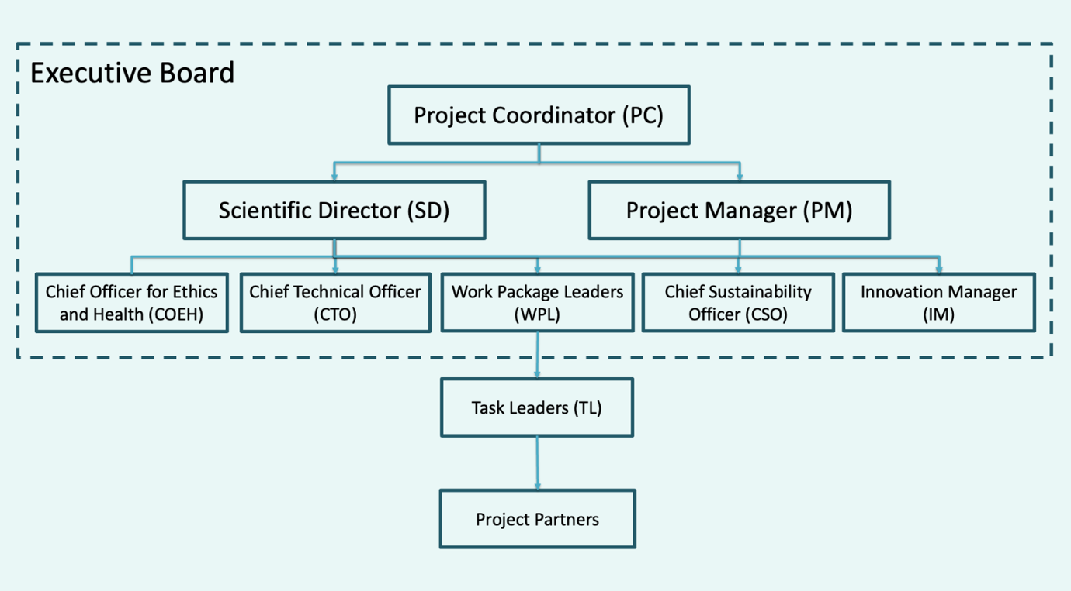
Figure 1 Executive Board

2.2. Data Providers

Types of Data

3.1. Physio-Chemical Properties of Indoor Air Pollutants in Different Environments

3.2 Biological (Human) Samples
3.3 Toxological Data

3.4 Chemical Structure Information

3.5 Geographical Locations

3.6 Contamination Levels

3.7 Data Formats
3.7.1 On-Line Databases
Relational, NoSQL, ObjectDB, XML, DB
3.7.2 Off-Line Files
MS Excel, MS Access, CSV Files
3.7.2 Web Services
3.8 Map of Data Providers to Types of Data

How Data are Managed

4.1. Open-Source / Open Data
Article 4. Open Data Principles
1. By default, the chemical monitoring data retrievable through the IPCHEM platform shall be made available to all User Groups under the conditions of Free, Full, Open and Timely access according to the “ European strategy for data”6 and the Open Data Directive7.
2. The chemical monitoring data retrievable through the IPCHEM platform shall be made available to all User Groups as single measurement data unless one or several of the exceptions listed below in Article 6 apply, or subject to specific conditions deriving from those exceptions.
3. If single measurement data is not available, the data should be made available to all User Groups at the highest degree of detail possible, unless one or several of the exceptions listed below in Article 6 apply, or subject to specific conditions deriving from those exceptions.
4. The data shall be provided with all the necessary attributes to facilitate their interpretation and shall be accompanied by the metadata to make them usable and understandable by the user, unless one or several of the exceptions listed below in Article 6 apply, or subject to specific conditions deriving from those exceptions.

4.2. FAIR

4.3. GDPR and Privacy

4.4. Creative Commons License

4.5. Granularity Level

4.6. Levels of Data

4.6.1 Metadata

4.6.2 Aggregated Data

4.6.3 Filtered and Generalised Single Measurement Data

4.6.4 Single Measurement Data

4.7 Data Restrictions

Demo of Data Platform / Front-End
Overview where to find which data
Search engine included
With automatic upload to IPCHEM if possible

IPCHEM Standards

6.1 Chemical Occurrence Data in IPCHEM
IPCHEM is structured into four modules, according to the chemical monitoring data categorisation: Environmental monitoring, Human Bio-Monitoring, Food and Feed, Products and Indoor Air

6.2 Contributors to IPCHEM
EU Member States Competent Authorities
Universities and Research Institutions
International non-governmental organisations
Any public and private institution collecting chemical monitoring data
European Commission Services,
European Executive and Decentralised Agencies

6.3 Purpose of IPCHEM
Discovering a chemical monitoring initiative for a specific substance and/or media
Getting information on the conditions of data use related to a specific data collection
Accessing documentation on the sampling and analytical methods used in the specific monitoring initiative

Data Forms
3 types, possibly merged into 1
The data forms of of sensor providers can be found in the Annex section.

Annex

Annex 1 – Data Forms

Deliverable D4.1
Data Management Plan

Work Package 4
MONITOR
Version: Final

This project has received funding from the European Union’s
Horizon Europe Framework Programme under grant agreement Nº 101057497.

